
STAFF SPIRITUALITY
“DIRECTIONS”

The Cross: Façade or Central Focus?


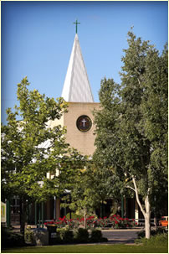



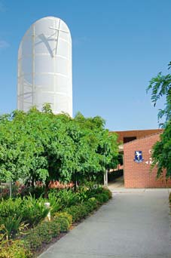


Most of our Lutheran Schools display the cross in a prominent place, often on some centrally located high point on the school campus, sometimes as part of a substantial logo usually in a location for optimum public view and definitely throughout the school community as part of uniforms, letterheads.

Some possible questions to ask ourselves:

- Overall, how well do we reflect the message of the cross in everything that we do?
- Are we PRETENDERS rather than being PASSIONATE PRO-ACTIVISTS about things spiritual? (Consider this in the light of DIRECTIONS: Why are we here? )
- Does the Gospel of Jesus intentionally inform the decision making process?
- Does the school take seriously its task of mission and ministry?
- Could we reasonably be accused of being just a private school – or worse, an elitist private school?
- Does a group of people meet regularly to discuss and plan spiritual growth strategies?
- Does the school intentionally put in place with high priority, a comprehensive and dynamic programme for the spiritual development of staff?
- Is such a programme given priority in the administrative calendar? (are spiritual development activities for staff put in place as “the BIG rocks”? )
- Is spiritual development material structured to provide for the nurture and further growth of those who are advanced in their faith journey, ad well as at a level to gently encourage and bring along those who are just starting out on their journey?
- Are we AUTHENTIC in our spirituality? (Do we tell it as it is rather than, for example, presenting devotions where we tell it like we think we should tell it, or like other people want to hear it? Do we liberate ourselves to share our faith struggles, rather than put on a false front? (See “REFLECTIONS : Hearing the words of Jesus” )
- Is regular prayer an integral part of the life of our school community?
- Does the school genuinely reflect Christianity in action through its daily operations? (consider James Ch 2:18 … “I will show you my faith by my actions”)
- Would an outsider be able to see and “feel” the Christian ethos of our school community?

